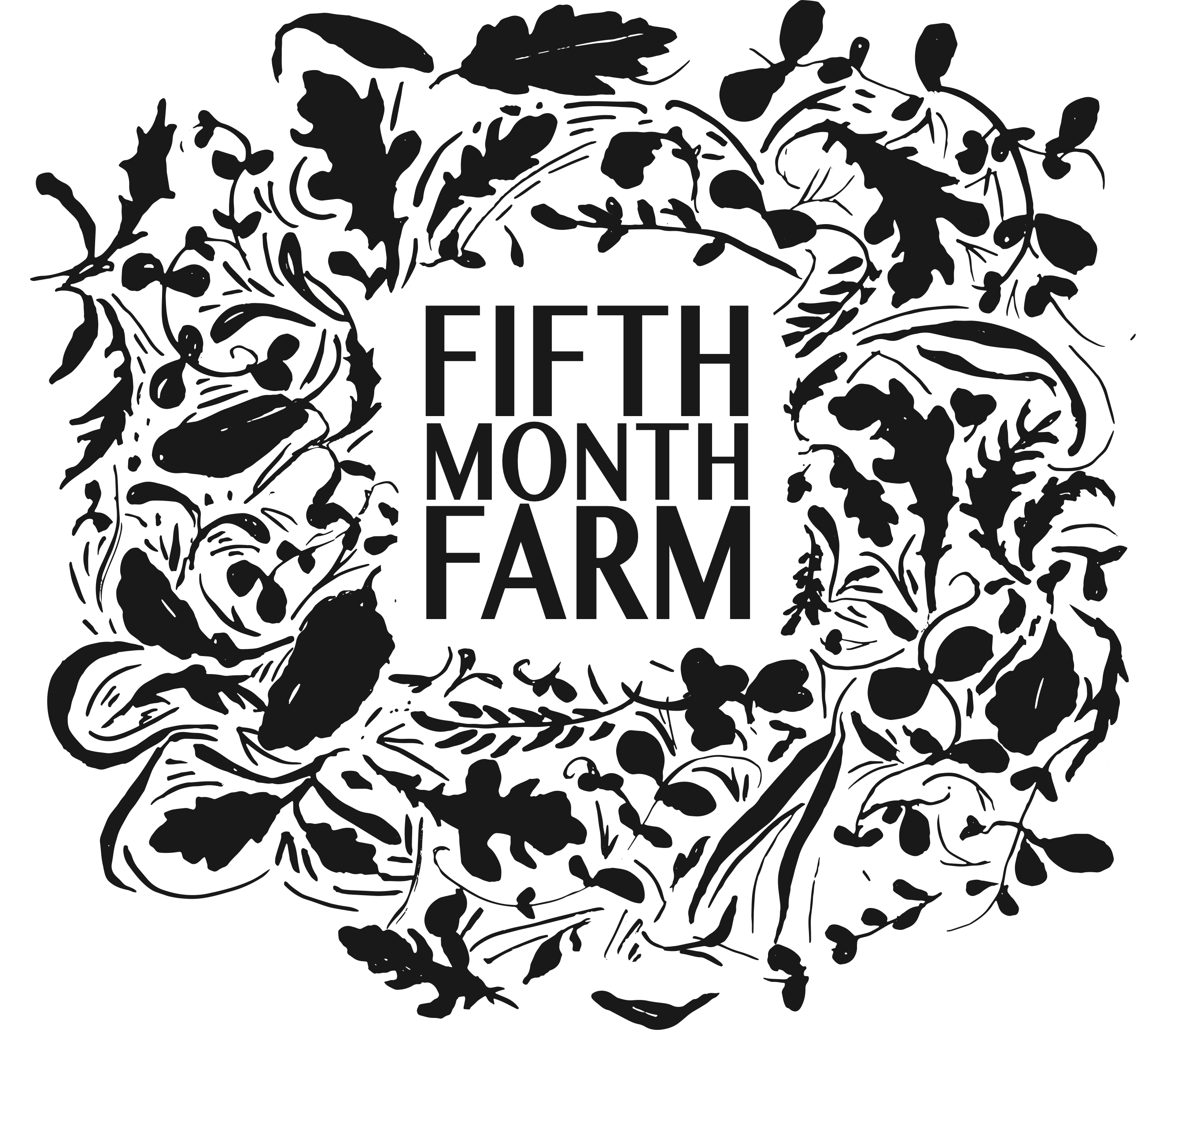

FIFTH MONTH FARM JOB APPLICATION

Fifth Month Farm is a small diversified vegetable farm. We are located in Mount Joy, Pennsylvania and grow using organic practices. We grow for our 75 member Winter C.S.A., sell our produce through our online store for home delivery, and sell to wholesale customers in the Lancaster area. We grow produce year round and grow many storage crops over the summer to sell during the winter months. The farm was founded in 2018 and is run by us, Devin and Kristi Barto. We are growing on a little under 5 acres of land that we lease. Our farm includes a heated propagation green house for transplant production, two large high tunnels, and one small storage tunnel. We grow over 50 different varieties of vegetables, as well as herbs, flowers and strawberries.

As a small farm, crew members work side-by-side with us, the farm owners, and participate in many aspects of intensive, small-scale vegetable production including seeding, transplanting, weeding, harvesting, washing and packing. Our farm operates with the use of a walk-behind tractor for bed preparation, mowing, etc. and occasionally a larger tractor for bigger jobs, but primarily we work with hand tools. As a member of our team, you will become very familiar with working with your hands. As such, working on a vegetable farm requires the ability to work in hot, cold, wet and changing conditions. It also requires the ability to safely lift 50 lbs and be on your feet for the entirety of the work day.

We enjoy that this work can be equally challenging and also, very fun. Crew members are self-motivated, detail-oriented and efficient and enjoy working in a professional, team environment.

Although prior farming experience is helpful to work with us, it is not always a requirement. Individuals with a desire to work outside and have an interest in the local food and farming community are encouraged to apply.

Thank you for your interest!

Warmly,
Kristi & Devin Barto

APPLICANT INFORMATION

Note: Feel free to use an additional piece of paper to answer the questions below if you need more room.

NAME:

HOME ADDRESS:

CITY, STATE,ZIP:

EMAIL ADDRESS:

PHONE NUMBER:

- Where did you learn about our farm?

- What areas of farming with us interest you? Circle all that apply:
    - Vegetables
    - Flowers
    - Washing and packing
    - Packing and organizing orders
    - Greenhouse and transplant production
    - List any others that come to mind:

- Please describe your farming/gardening or outdoor labor experience or other relevant experiences. (Paid employment, classes, volunteer work,etc.)

- Do you have experience with the following:
  - Basic gardening tools (shovels, hoes, rakes, etc.) : Y / N
  - Basic construction tools (hammers, drills, saw, etc.) : Y / N
  - Plant identification (weeds, vegetables, flowers, etc.) : Y / N

5. Do you have any experience handling food or knowledge of food safety practices?

6. Please describe why you are most interested in working on our farm and feel free to elaborate on any of your interests circled in question 2.

7. Please attach your resume and submit this form to us via email at info@fifthmonthfarm.com

