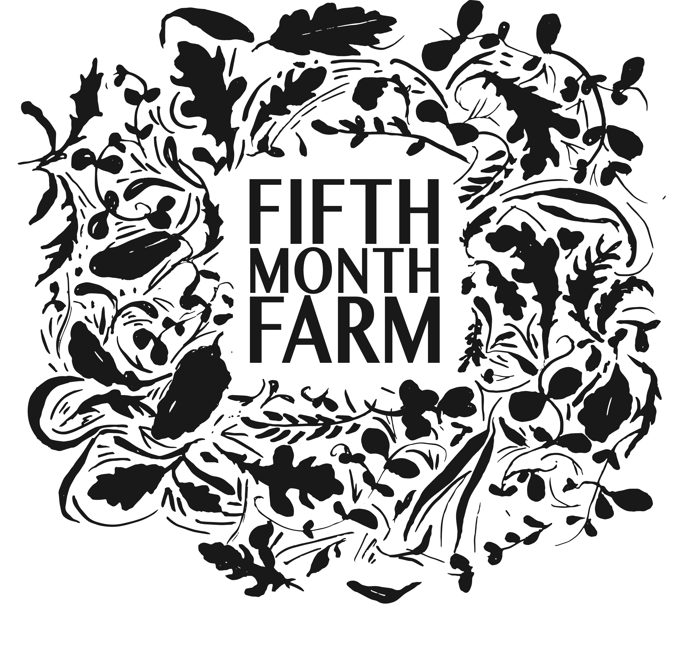

FIFTH MONTH FARM JOB APPLICATION

Fifth Month Farm is a small, diversified vegetable farm. We are in Mount Joy, Pennsylvania and grow using organic practices. We grow year-round for our Summer and Winter C.S.A.s, serving members in the Lancaster County and Philadelphia area. We grow many storage crops over the summer to sell during the winter months. The farm was founded in 2018 and is run by us, Devin and Kristi Barto. We are growing on a little under 5 acres of land that we lease. Our farm includes a heated propagation green house for transplant production, three large high tunnels, and one small storage tunnel. We grow over 50 different varieties of vegetables, as well as herbs, and flowers.

As a small farm, crew members work side-by-side with us, the farm owners, and participate in many aspects of intensive, small-scale vegetable production including seeding, transplanting, weeding, harvesting, washing, and packing. Our farm operates with the use of a mid-sized tractor as well as a walk-behind tractor, but we primarily work with hand tools. As such, working on a vegetable farm requires the ability to work in hot, cold, wet, and changing conditions. It also requires the ability to safely lift 50 lbs and to be on your feet for the entirety of the workday.

We enjoy that this work can be equally challenging and very fun. A good sense of humor and positivity is an important part of how we operate. Crew members are self-motivated, detail-oriented, and efficient and enjoy working in a positive, professional, team environment.

Although prior farming experience is preferable, it is not always a requirement. Individuals with experience working outdoors, in trades, or in the food industry have successfully worked with us in the past.
​
Thank you for your interest!
Warmly,
Kristi & Devin Barto

APPLICANT INFORMATION

Note: Feel free to use an additional piece of paper to answer the questions below if you need more room.

NAME:

HOME ADDRESS:

CITY, STATE,ZIP:

EMAIL ADDRESS:

PHONE NUMBER:

- Which position are you applying for?

- Where did you learn about our farm?

- What areas of farming with us interest you? Circle all that apply:
    - Vegetables
    - Flowers
    - Washing and packing
    - Packing and organizing orders
    - Greenhouse and transplant production
    - List any others that come to mind:

- Please describe your farming/gardening or outdoor labor experience or other relevant experiences. (Paid employment, classes, volunteer work,etc.)

- Do you have experience with the following:
  - Basic gardening tools (shovels, hoes, rakes, etc.) : Y / N
  - Basic construction tools (hammers, drills, saw, etc.) : Y / N
  - Plant identification (weeds, vegetables, flowers, etc.) : Y / N

5. Do you have any experience handling food or knowledge of food safety practices (and/or experience handling flowers, if applying for a floral position)?

6. Please describe why you are most interested in working on our farm and feel free to elaborate on any of your interests circled in question 2.

7. Please attach your resume and submit this form to us via email at info@fifthmonthfarm.com

We will contact you once we have received and reviewed your application.

Fifth Month Farm is an equal opportunity employer. We celebrate diversity and inclusion are a safe space for all. We prohibit discrimination and harassment of any kind based on race, color, sex, religion, sexual orientation, national origin, disability, genetic information, pregnancy, or any other protected characteristic as outlined by federal, state, or local laws.

